Linux Commands

CentOS Linux commands key divided on the functionality.

1.Crontab:

It is used as a job scheduler to execute tasks. *cron* is the system process which will automatically perform tasks for you according to a set schedule. The schedule is called the crontab, which is also the name of the program used to edit that schedule.

**Linux Crontab Format**

MIN HOUR DOM MON DOW CMD

MIN Minute field 0 to 59

HOUR Hour field 0 to 23

DOM Day of Month 1-31

MON Month field 1-12

DOW Day Of Week 0-6

CMD Command Any command to be executed.

2. **pwd:** To know which directory you are in, you can use the “pwd” command. It gives us the absolute path, which means the path that starts from the root.



3. **ls** — Use the "ls" command to know what files are in the directory you are in.



4. **cd** — Use the **"cd"** command to go to a directory.



5. **mkdir & rmdir**— Use the **mkdir** command when you need to create a folder or a directory. And rmdir command is used to remove an empty directory.





6. **rm**: To delete a directory containing files, use **rm**.

7. **touch** — The**touch** command is used to create a file. It can be anything, from an empty txt file to an empty zip file.



Like touch new.txt

8. man - To know more about a command and how to use it, use the **man** command. It shows the manual pages of the command.

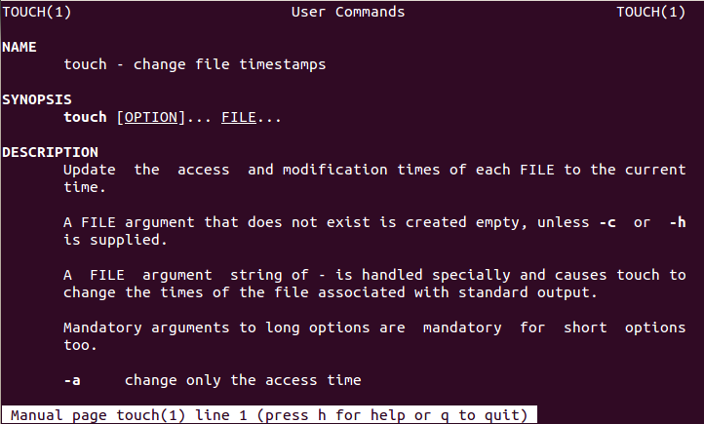

9. **cp** — Use the **cp**command to copy files through the command line. It takes two arguments: The first is the location of the file to be copied, the second is where to copy.

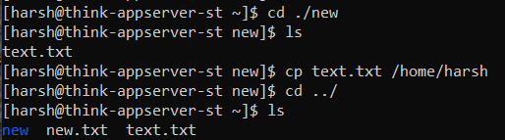

10. **locate** — The **locate** command is used to locate a file in a Linux system. This command is useful when you don't know where a file is saved or the actual name of the file. Using the -i argument with the command helps to ignore the case (it doesn't matter if it is uppercase or lowercase). So, if you want a file that has the word “hello”, it gives the list of all the files in your Linux system containing the word "hello" when you type in “**locate -i hello**”. If you remember two words, you can separate them using an asterisk (*). For example, to locate a file containing the words "hello" and "this", you can use the command “**locate -i *hello*this”.**

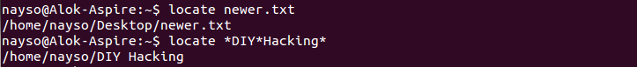

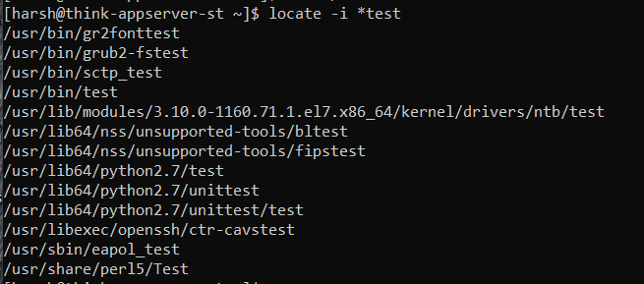

11. **cat**— Use the **cat** command to display the contents of a file



12. **echo**— The "**echo**" command helps us move some data, usually text into a file.

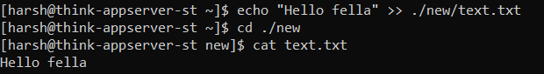

13. **df**— Use the **df**command to see the available disk space in each of the partitions in your system.

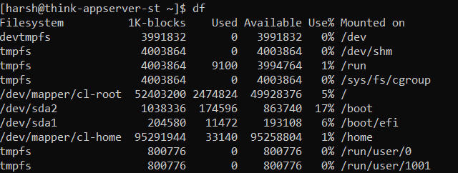

14. **du** — Use **du** to know the disk usage of a file in your system. If you want to know the disk usage for a particular folder or file in Linux, you can type in the command **df** and the name of the folder or file.



15. You can also use the command “**ls -lah**” to view the file sizes of all the files in a folder.

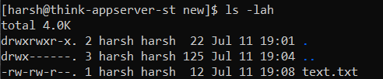

16. **uname** — Use **uname** to show the information about the system your Linux distro is running.  This prints the kernel release date, version, processor type, etc.



17. **sudo** — **sudo** stands for "SuperUser Do". So, if you want any command to be done with administrative or root privileges, you can use the **sudo** command.

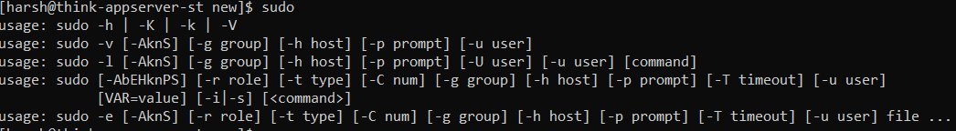

_____________________18-07-2022________________________________

18. ping: **Ping** measures the round-trip time for messages sent from the originating host to a destination computer that are echoed back to the source.

Below command will send 10 packages to google.com and track the amount of time it took to come.

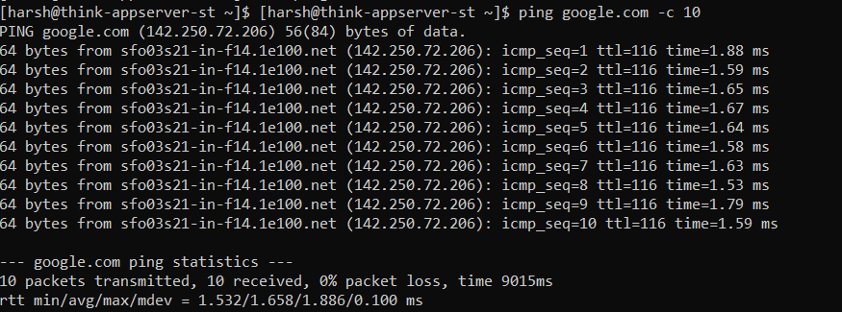

19. nslookup: nslookup is the name of a program that **lets an Internet server administrator or any computer user enter a host name (for example, "whatis.com") and find out the corresponding IP address or domain name system (DNS) record**.

20. traceroute: A **traceroute** provides a map of how data on the internet travels from your computer to its destination.

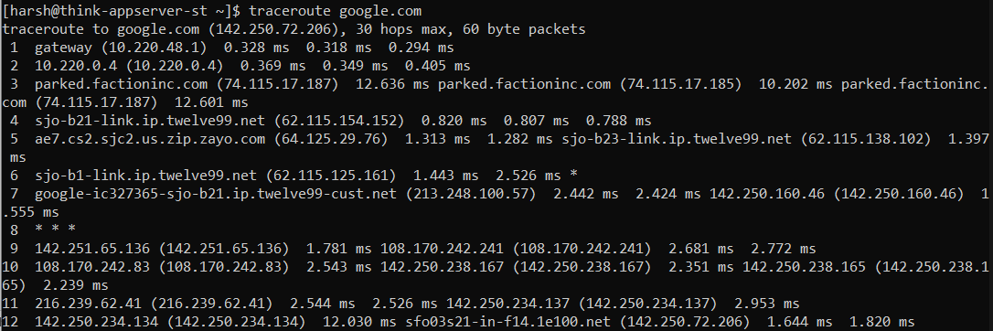

21. dd: **dd** is a command-line utility for **Unix** and **Unix**-like operating systems whose primary purpose is to convert and copy files.

Mainly this is used to make backups and drive copies in the Unix-system and executed like:

Dd if = [input_file] of = [outpu_file]

Like 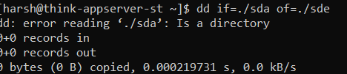

22. find: The find command in UNIX is **a command line utility for walking a file hierarchy**. It can be used to find files and directories and perform subsequent operations on them. It supports searching by file, folder, name, creation date, modification date, owner and permissions.

find [where to start searching from] [expression determines what to find] [-options] [what to find]

